**INPUT**

**Python (Front-end)**

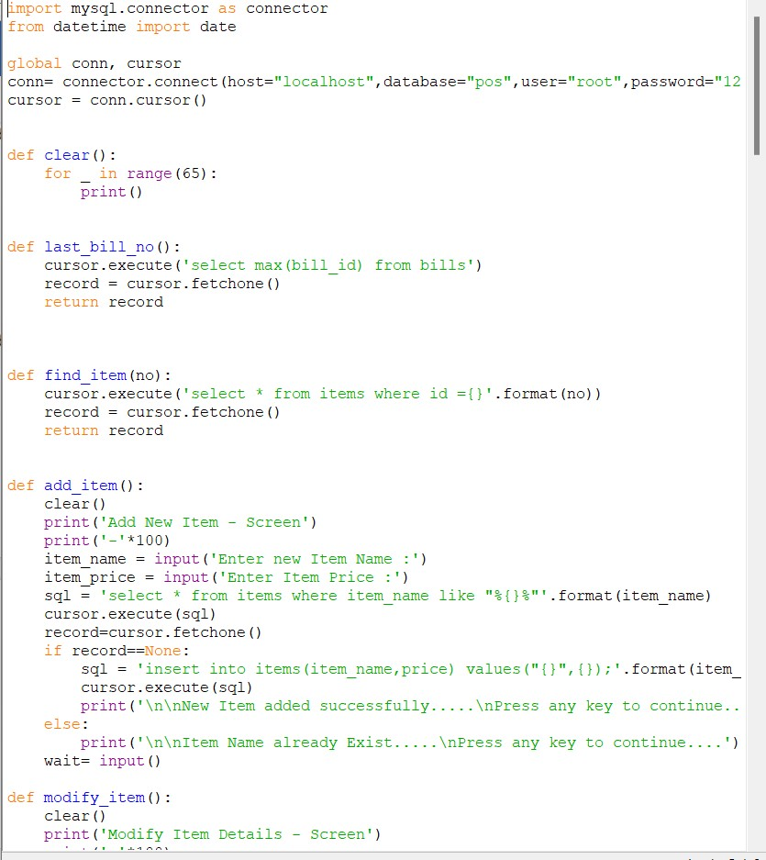

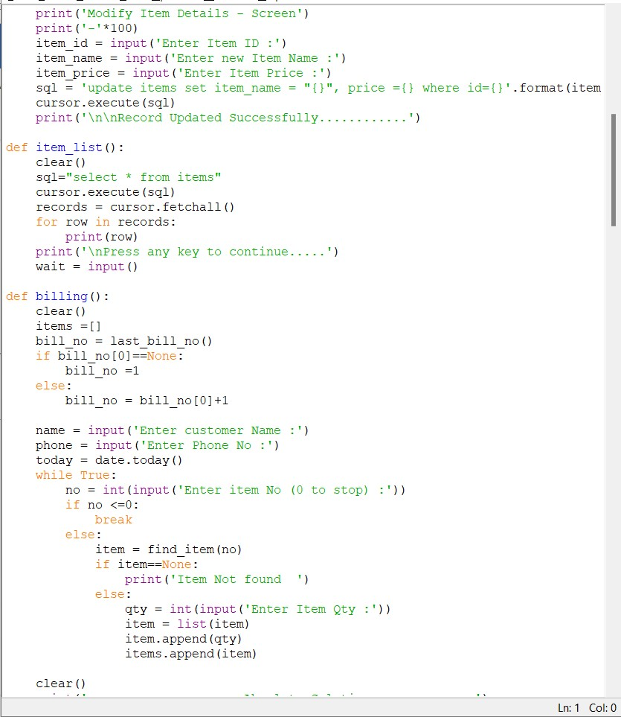

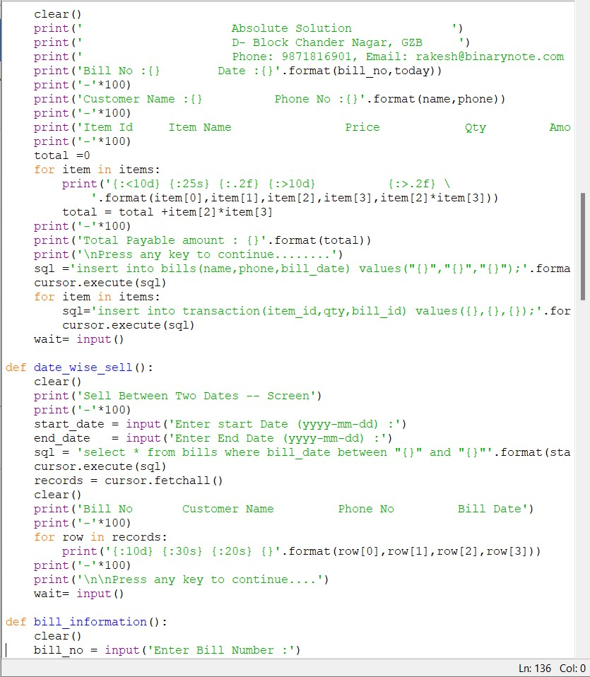

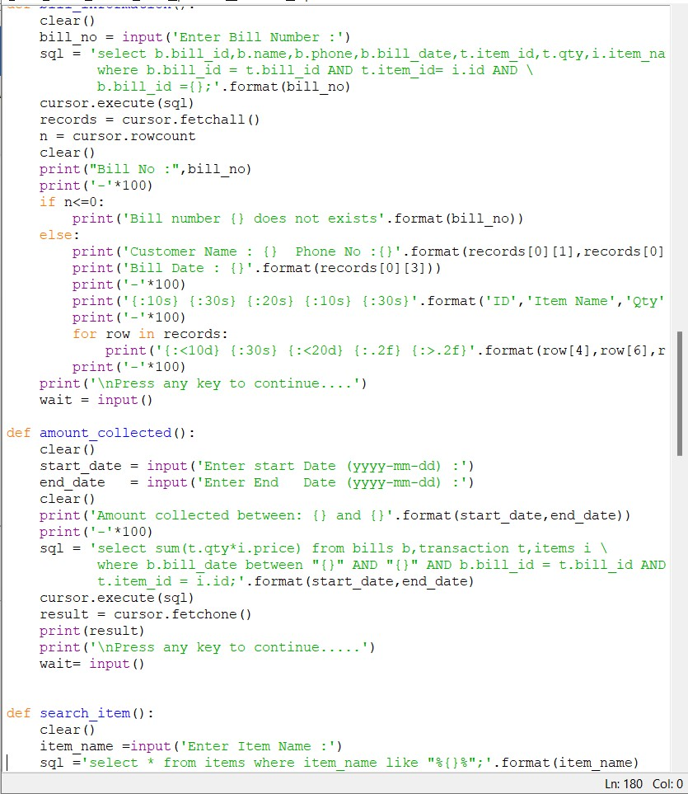

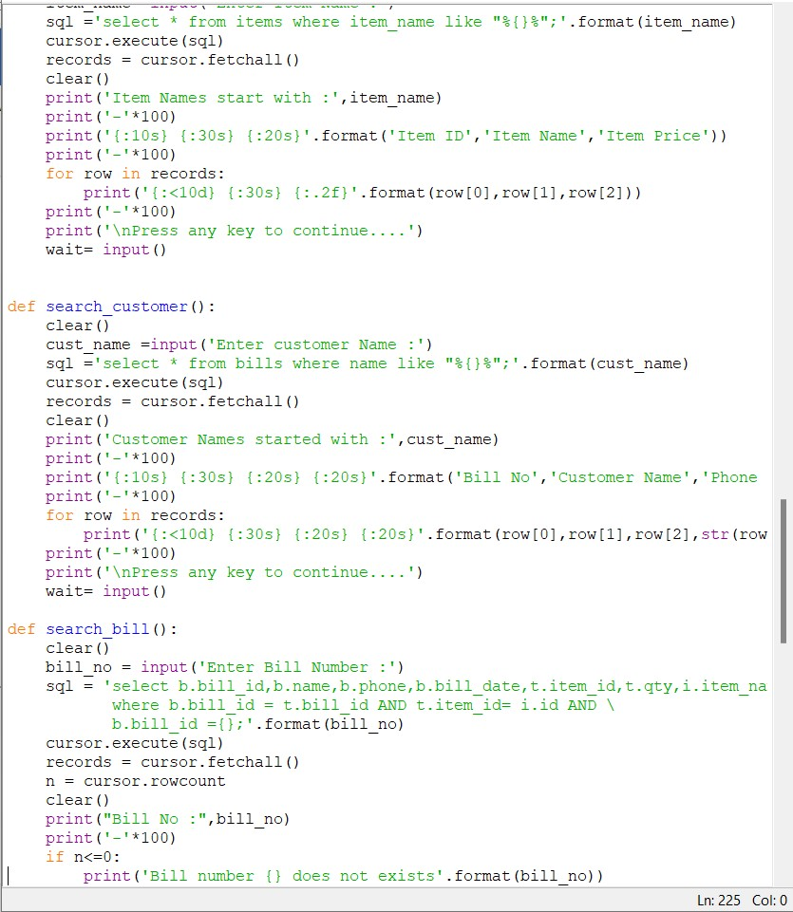

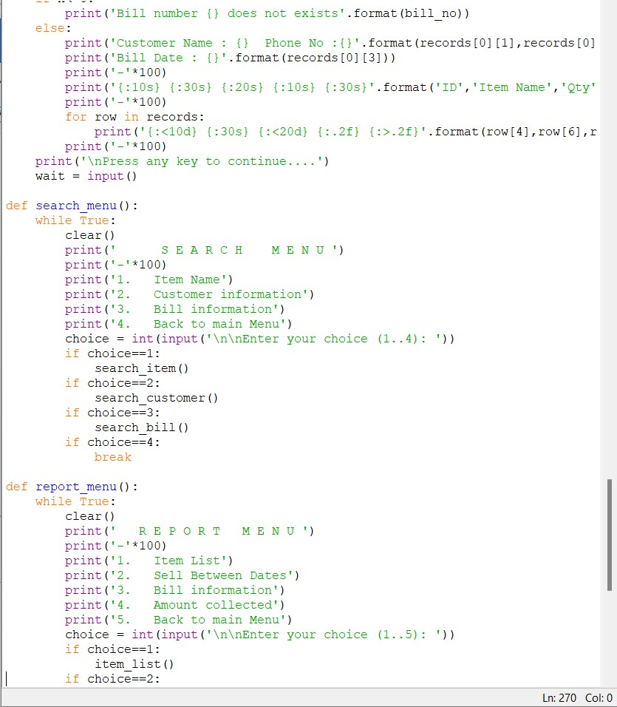

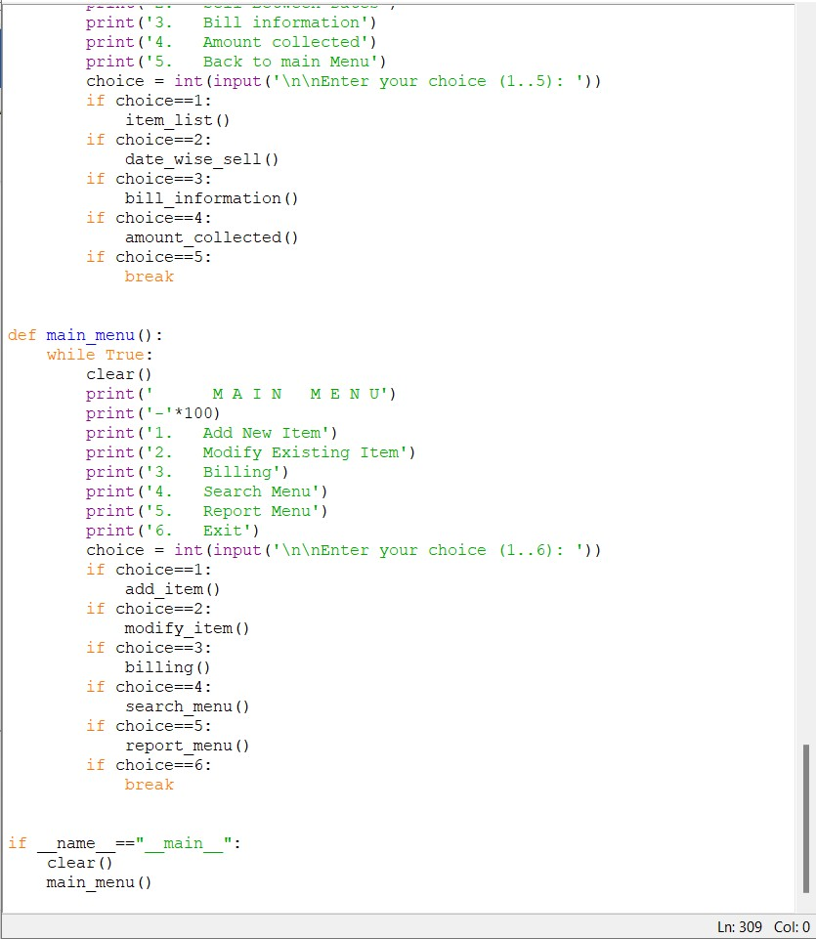

**MySQL (Back-end)**

SET SQL_MODE = "NO_AUTO_VALUE_ON_ZERO";

START TRANSACTION;

SET time_zone = "+00:00";

DROP TABLE IF EXISTS `bills`;

CREATE TABLE IF NOT EXISTS `bills` (

`bill_id` int(11) NOT NULL AUTO_INCREMENT,

`name` char(30) DEFAULT NULL,

`phone` char(15) DEFAULT NULL,

`bill_date` date DEFAULT NULL,

PRIMARY KEY (`bill_id`)

) ENGINE=MyISAM AUTO_INCREMENT=8 DEFAULT CHARSET=latin1;

INSERT INTO `bills` (`bill_id`, `name`, `phone`, `bill_date`) VALUES

(3, 'ramji', '23423423', '2021-03-16'),

(4, 'pushkar', '1122334455', '2021-03-05'),

(5, 'rakesh', '9871816901', '2021-03-18'),

(6, 'swarnima', '9988776655', '2021-03-18'),

(7, 'ra', '2322', '2021-03-18');

DROP TABLE IF EXISTS `items`;

CREATE TABLE IF NOT EXISTS `items` (

`id` int(11) NOT NULL AUTO_INCREMENT,

`item_name` char(30) DEFAULT NULL,

`price` float(8,2) DEFAULT NULL,

PRIMARY KEY (`id`)

) ENGINE=MyISAM AUTO_INCREMENT=8 DEFAULT CHARSET=latin1;

INSERT INTO `items` (`id`, `item_name`, `price`) VALUES

(1, 'fan', 1250.00),

(2, 'Tubelight', 250.00),

(3, 'Bulb-20', 350.00),

(4, 'Bulb-40', 300.00),

(5, 'Bulb-60', 380.00),

(6, 'mosquito-racket', 380.00),

(7, 'pan', 10.00);

DROP TABLE IF EXISTS `login`;

CREATE TABLE IF NOT EXISTS `login` (

`id` int(11) NOT NULL AUTO_INCREMENT,

`name` char(30) DEFAULT NULL,

`pwd` char(30) DEFAULT NULL,

PRIMARY KEY (`id`)

) ENGINE=MyISAM AUTO_INCREMENT=2 DEFAULT CHARSET=latin1;

INSERT INTO `login` (`id`, `name`, `pwd`) VALUES

(1, 'rakesh', 'ramji');

DROP TABLE IF EXISTS `transaction`;

CREATE TABLE IF NOT EXISTS `transaction` (

`id` int(11) NOT NULL AUTO_INCREMENT,

`item_id` int(11) DEFAULT NULL,

`qty` int(11) DEFAULT NULL,

`bill_id` int(11) DEFAULT NULL,

PRIMARY KEY (`id`)

) ENGINE=MyISAM AUTO_INCREMENT=17 DEFAULT CHARSET=latin1;

INSERT INTO `transaction` (`id`, `item_id`, `qty`, `bill_id`) VALUES

(1, 4, 1, 1),

(2, 3, 1, 1),

(3, 1, 1, 1),

(4, 1, 1, 2),

(5, 5, 1, 2),

(6, 6, 1, 2),

(7, 3, 1, 2),

(8, 2, 1, 2),

(9, 1, 10, 4),

(10, 2, 20, 4),

(11, 3, 12, 4),

(12, 1, 2, 5),

(13, 1, 2, 5),

(14, 1, 1, 6),

(15, 2, 3, 6),

(16, 4, 10, 6);

COMMIT;

Output





